**Image Layering:**

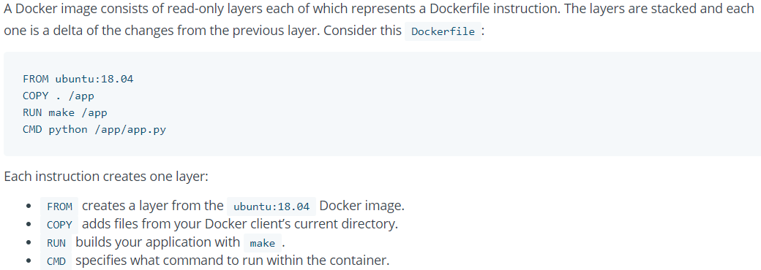



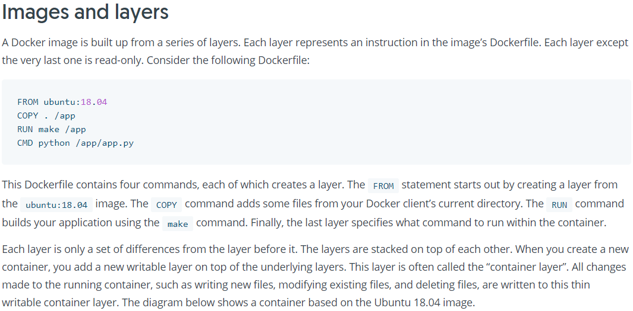

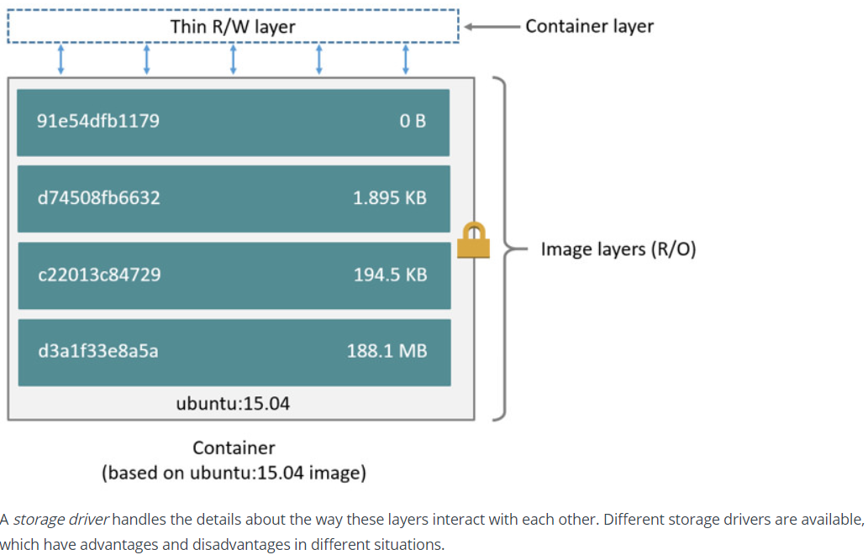

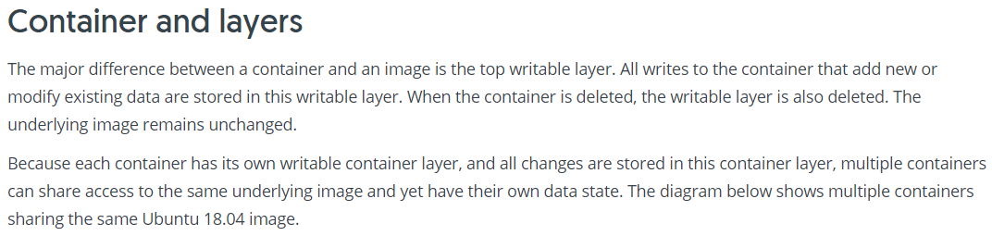

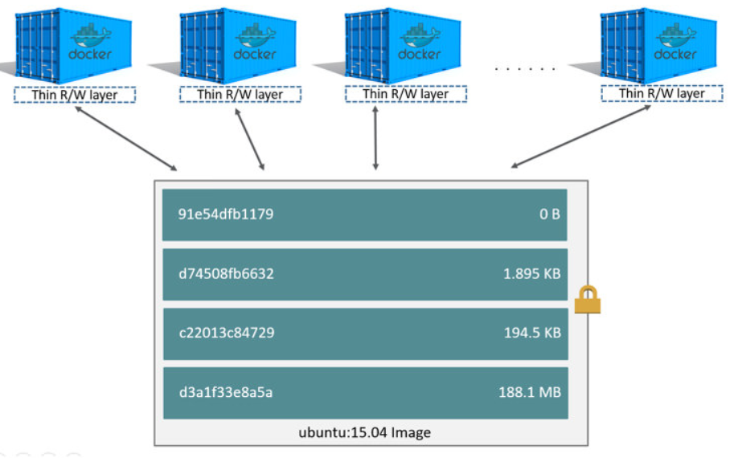

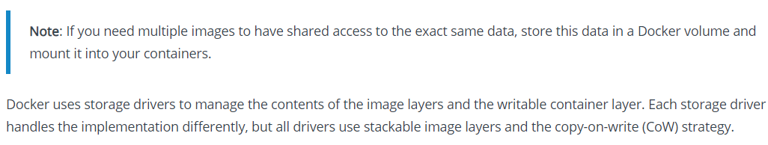

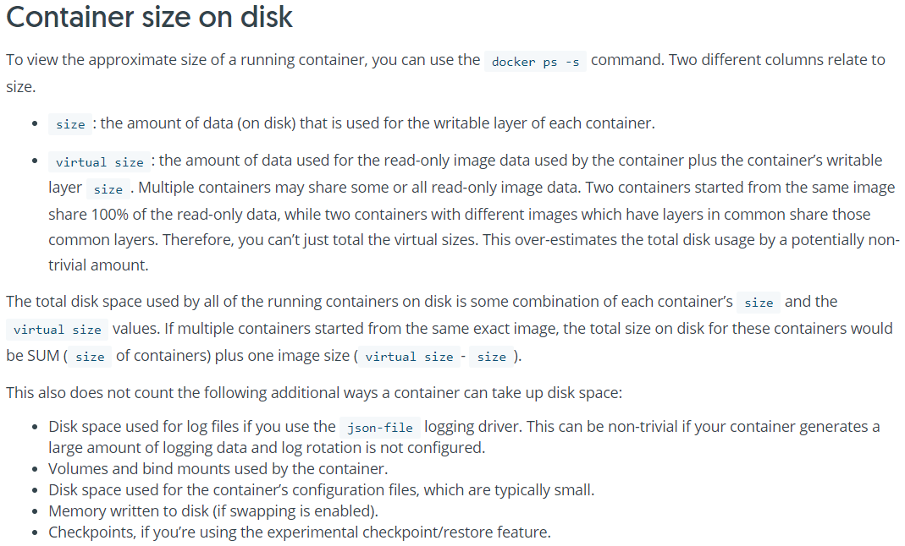

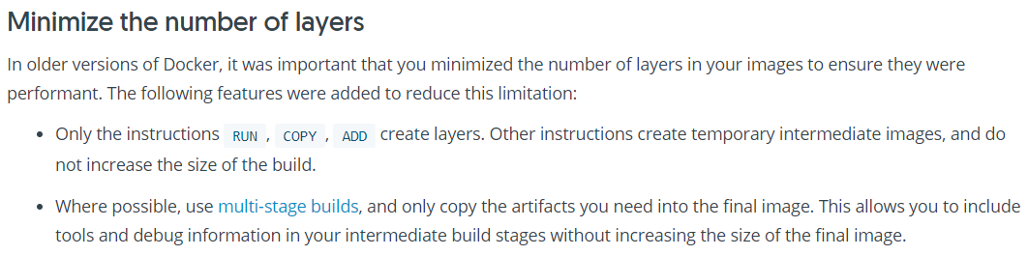

**Where are the layers found?**

Every image layer has hash values which follows sha256 algorithm

* When content is same, it will always give same hash value. this is how it compares with the hash values
* The hash values stored in docker/images or containers directory under /var/lib



* Hash is way to find out whether content is same or not
* If we run image or container as many times if the content is same, we will get the same hash

Whenever we want to get any details of docker image or container, use inspect command

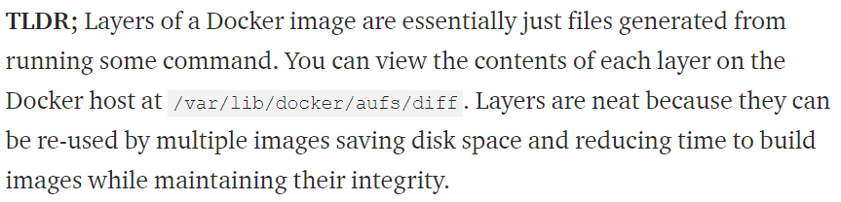

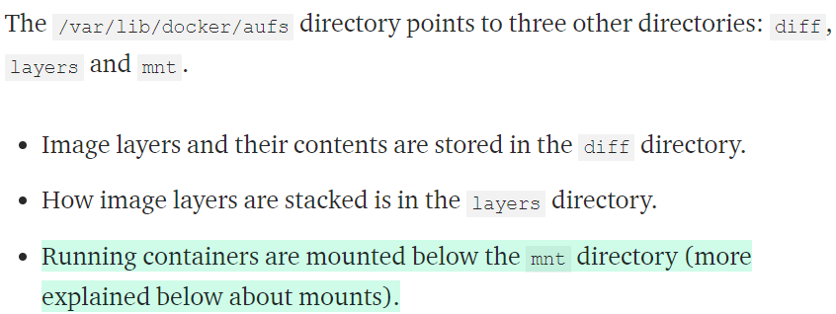

**If we delete this data, then the docker images will also be removed**

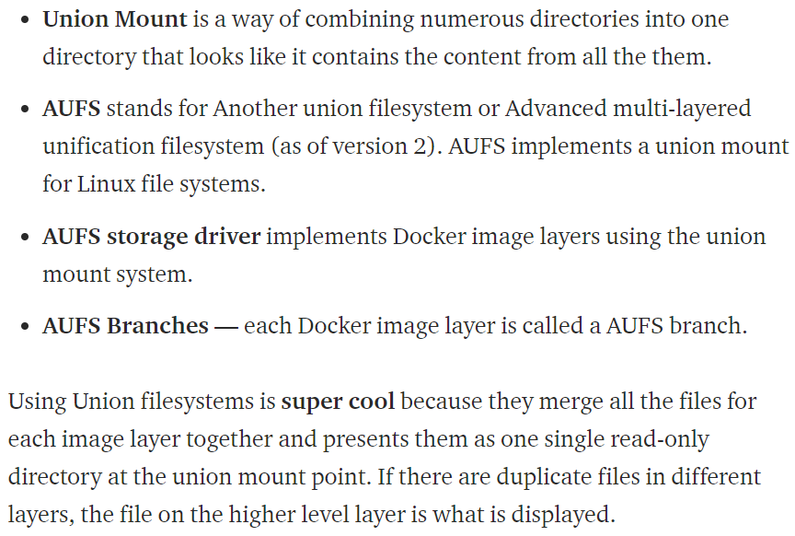

++++++++++++++++++++++++++++++++++++++++++++++++++++++++++++++++++++++++++++++++++

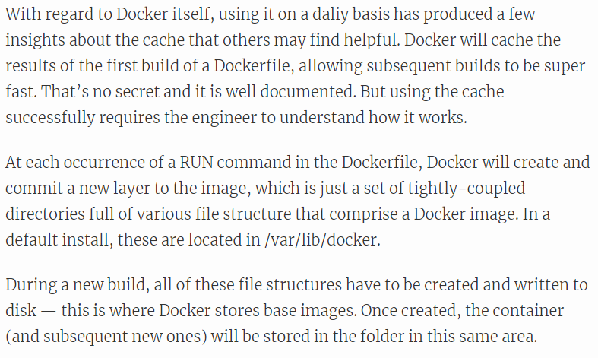

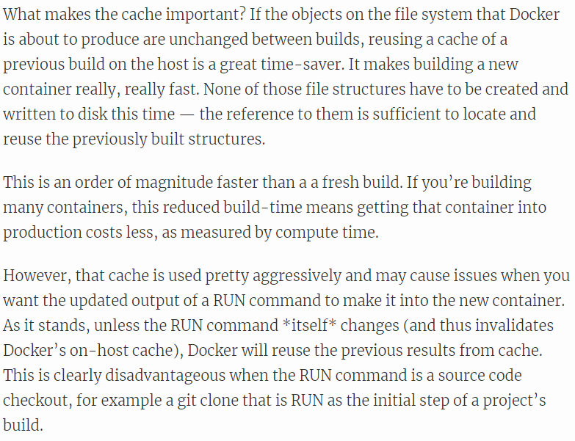

**Build Cache:**

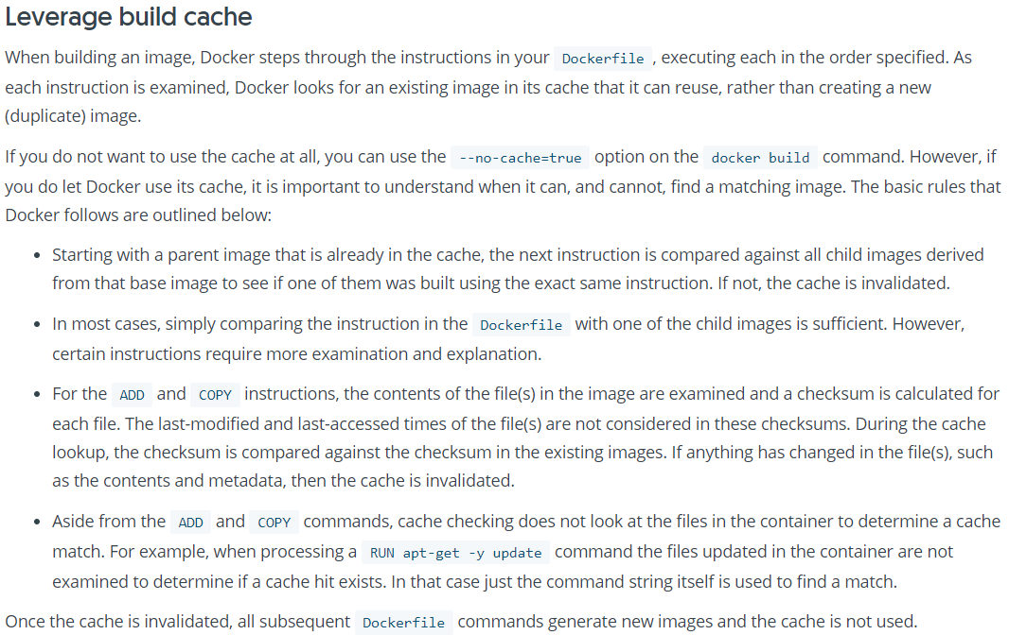

**Intermediate Containers:**

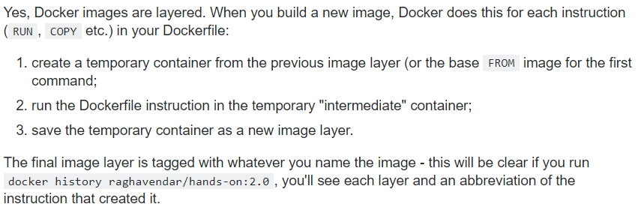

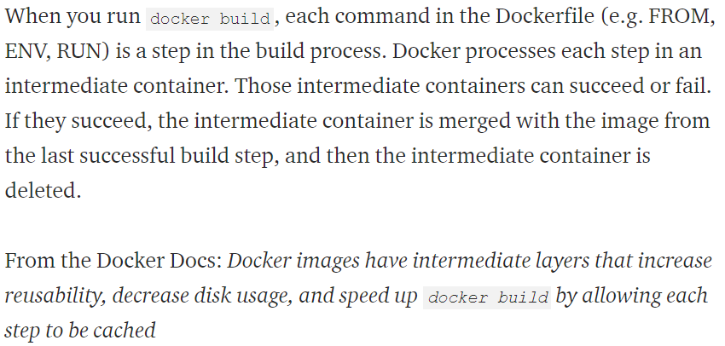

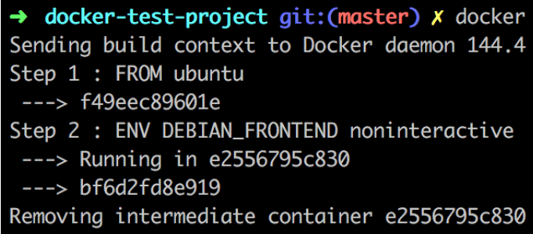

As above, we can see step2 was executed in a container and then the container was removed